ZŠ Slobodného slovenského vysielača, Skuteckého 8, Banská Bystrica, Slovakia

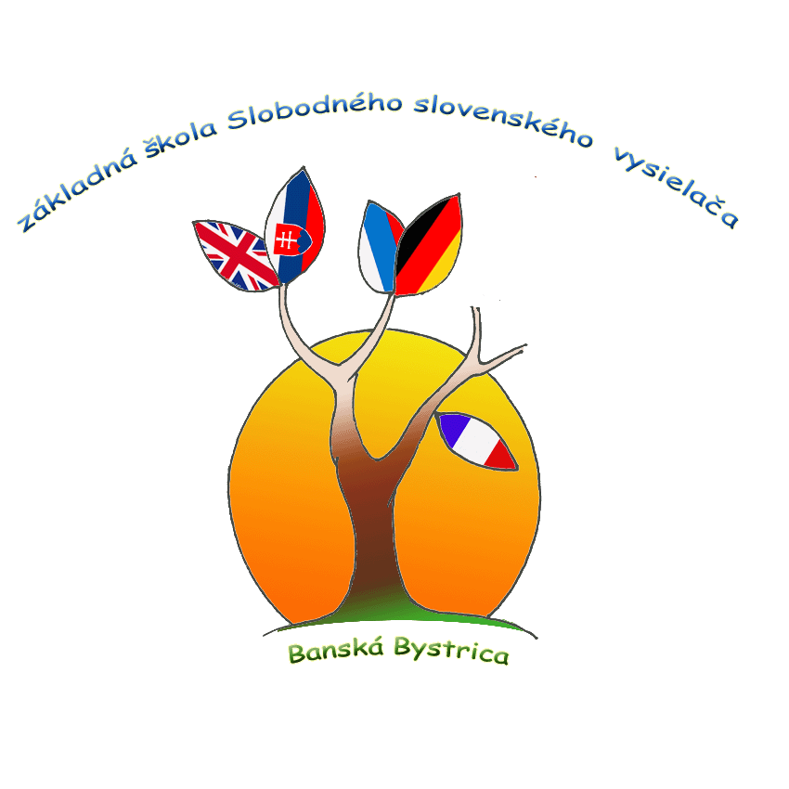

Admission policy
Policy written by : | Leadership team
Version number: | 01
Applicable to: | Students of international programme
Approved on: | March 2023
Review Cycle: | 3 years
Date of Next Review: | March 2026
Related Policies: | Inclusion Policy, Language Policy

Mission Statement at ZŠ Slobodného slovenského vysielača, Skuteckého 8

Together with parents, we strive to educate active, responsible, caring, satisfied, and lifelong learners. We develop the key competencies and skills needed for them to be able to create a better and peaceful world in a constantly changing and culturally diverse global society.

Our vision

A graduate of our school is a smart, communicative, caring young person who is prepared to further develop his abilities and skills for application in life in a global society.

Our values

freedom, responsibility, caring for people and the planet, trust, creativity, honesty, justice, tolerance, courage, empathy, decency

Purpose of Admission Policy at ZŠ Slobodného slovenského vysielača, Skuteckého 8
The purpose of this documents is to communicate to all stakeholders the requirements for enrolment in international programme at Základná škola SSV and to establish the responsibility of all stakeholders relate to admission at our school.
Policy objectives:
- To ensure that the school receives the maximum possible admission without compromise.
- Have a fair and transparent policy for all parents.
- Facilitate the admission process for parents and students.
- To ensure that students who are admitted into the program have the necessary skills, motivation, and commitment to succeed in the rigorous academic and personal development program offered by the MYP curriculum.
- To promote diversity and inclusivity by admitting students from a range of backgrounds and experiences.
Pupils will be admitted to the MYP based on the interest of pupils and parents from the two existing classes of our primary school in their fourth grade. The parents fill out the application form. Subsequently, students will take exams in English and mathematics, since studying in a language other than their mother tongue is more difficult for them. Not all students are interested in studying at the MYP, due to the English language of instruction. One class in the grade will remain with Slovak as the language of instruction and will be educated according to the national curriculum. Pupils can be admitted later to higher grades, especially students who come from abroad. If students from other schools in the area are interested in studying there, they can be accepted if there is a vacancy in the grade and they can pass the English language exams. Information about free places will be provided by the school management on the phone number+421484125950.

Middle Year Programme
Pupils who decide to study in the classroom according to the international program and who successfully pass tests in mathematics and the English language at the end of the fourth grade will have an increased number of English language lessons in the 5th grade. In the other subjects, teaching will take place using the CLIL method. In the following grades, it will be: the 6th grade, for preMYP - year 11-12, the 7th grade MYP 1 - year 12-13, the 8th grade MYP 2 - year 13-14, and the 9th grade MYP 3 - year 14-15.
The admission policy of the school ensures a fair and transparent admission system and prevents unfair discrimination based on disability, gender, religion, or belief. Furthermore, the policy ensures that proper admission procedures are followed for each application for admission received

Admission procedure:
STEP 1: Submission of documents and application form
All documents and applications for admission are handed over to parents, legal guardians and returned to the school management after they have been completed. Application Form Request must signed by the parents, legal guardians.The application form is bilingual, also published on the school's website, especially for students who have not attended the school before. Please note that if you do not submit any of the needed documents, the admission process will be considered incomplete. Application Form Request must signed by the parents, legal guardians.
After receiving the application form, students will be registered for admission tests in English language and Mathematics.

STEP 2: English and Math test
It is mandatory to pass these tests.
Test specifications will be published on the school's website no later than 4 weeks before the exam.
English: The test paper will be designed to test the student's ability to meet the ISCED 1 – national programme language acquisition requirements.
Mathematics: The test paper will be designed to test the student's ability to meet the mathematics requirement at ISCED 1 national programme mathematics requirements.
A student who is applying for a higher year must take the English language exams for the relevant year and provide evidence of certificates from the previous school. If the student is from abroad, it is necessary to provide an official translation of the last certificate into the Slovak language.

STEP 3: Communication of admission status
The school will inform you about your child’s admission status by post or via E-government no later than 7 days after the admission test. The admission decision is issued bilingually.

STEP 4: Confirmation of participation
When parents, legal guardians receive written notification of your child's acceptance, they must confirm the acceptance with their signature within the deadline specified in the document.
Selection Criteria for admission in MYP
English: 75 % minimum score
Maths: 60 % minimum score.
In all admissions cases, the head of school makes the final decision.

Students with special educational needs (SEN)

Our school is open to all children, including children with special needs. Unfortunately, the building's architecture does not allow for the adaptation of the educational space for children with physical disabilities who cannot move up the stairs and require a wheelchair. If the child has a known special need, such as dyslexia, autism, lack of interest in writing, slow learning, attention disorders, hearing impairment, etc., details of the same should be communicated while applying for admission. We recommend that you consult with a psychologist at the CPP centre before submitting your application, due to the difficulty of studying in a language other than your mother tongue. The psychologist's recommendation should be attached to the application. You should be aware that the admission process for candidates with special needs may be different and may take longer. Additionally, the class teacher at the primary level of education will comment on the acceptance.The School Counsellor reviews applications identified as potential SEN students. The counsellor and psychologist give recommendations on how to proceed with entrance exams in English and mathematics.
This may include:
- higher time allowance
- possibility of typing on the computer
- oral interview
- assistant's help
Responsibilities

When enrolling in ZŠ Slobodného slovenského vysielača, Skuteckého 8, it is the duty of parents or legal representatives to provide the school with evidence, including applications and all other required documentation – it applies especially to students who have not been students of the school until now.
Iit is the responsibility of parents to inform the school about the possible learning disabilities or special needs through the results of diagnostics from a pedagogical-psychological centre (CPP). The School Counsellor review any applications that are identified as potential SEN students.
The MYP coordinator has to check all documents and the suitability of applicants to study at the Základná škola SSV Banská Bystrica
Mathematics and language teachers are responsible for preparing suitable admission procedures.
It is the students' responsibility to take the tests.
It is the responsibility of all educators, professionals, parents, students, and all other stakeholders to remove barriers and create a friendly environment.

V Banskej Bystrici dňa 15. 3. 2023 Mgr. Zuzana Sedláčeková
Head of school

Mgr. Izolda Kerner
Coordinator MYP

