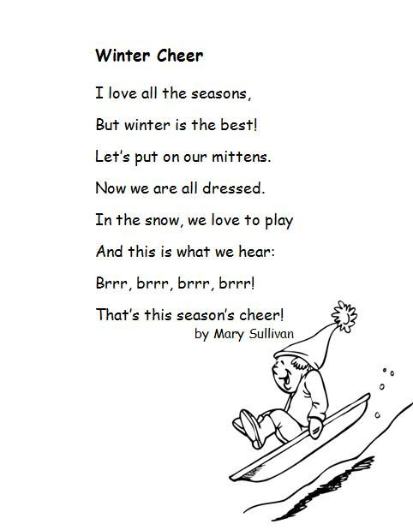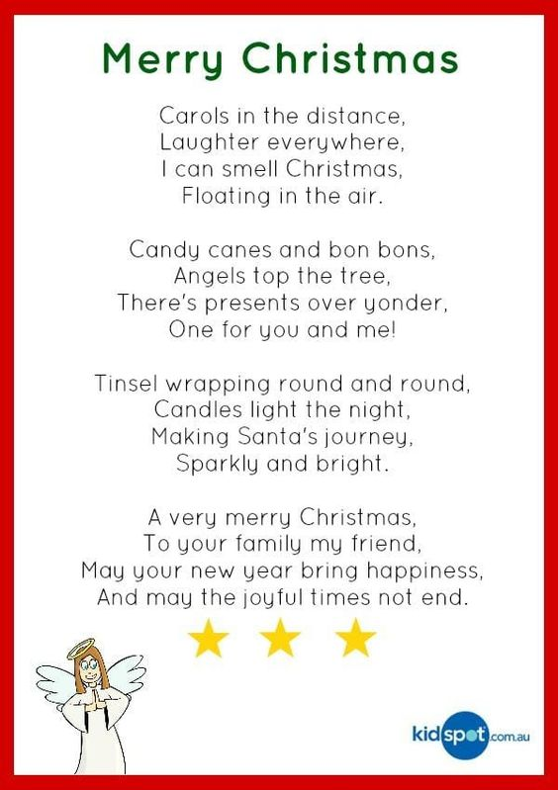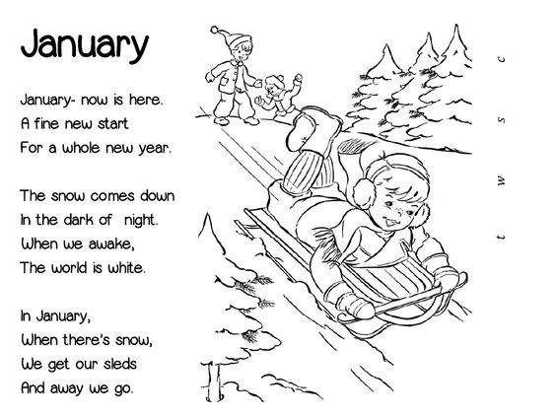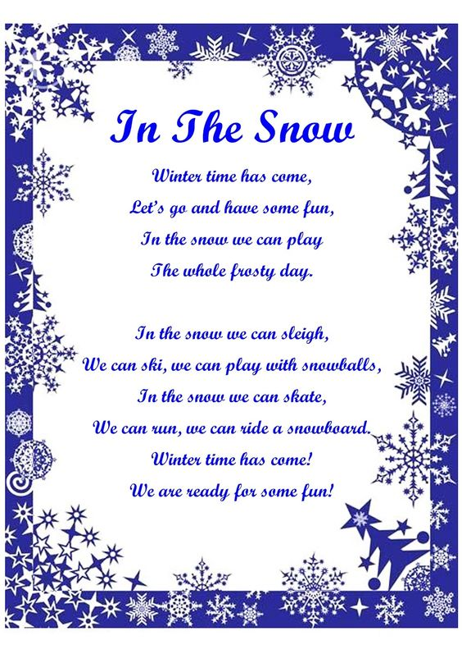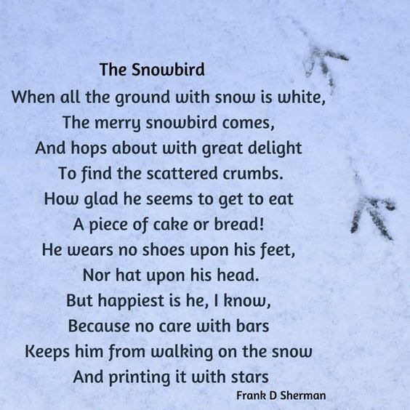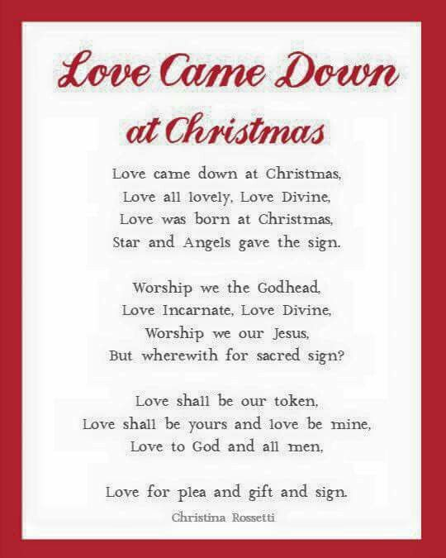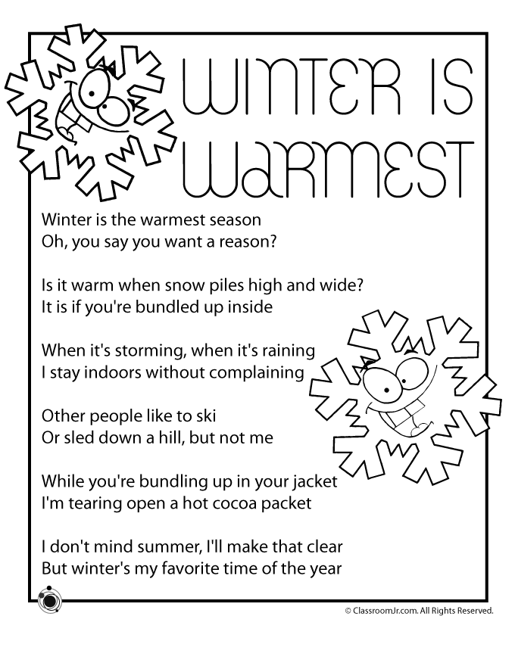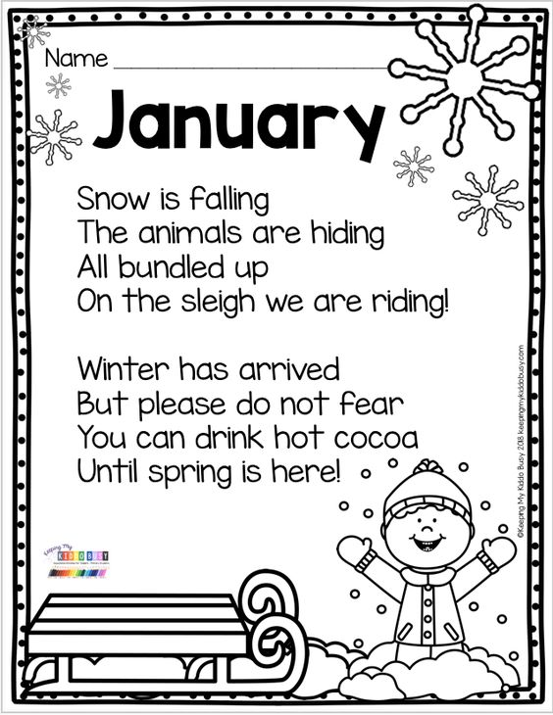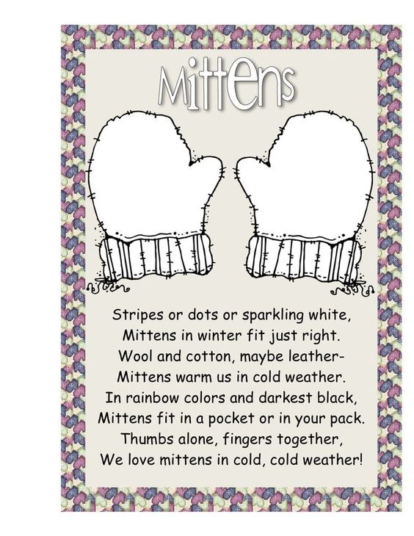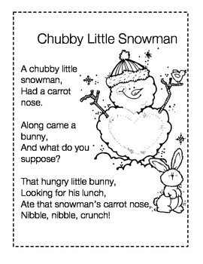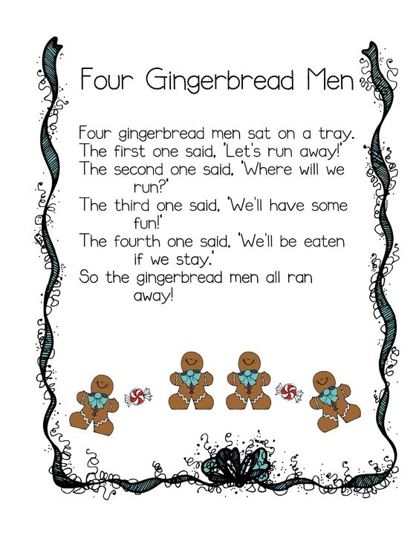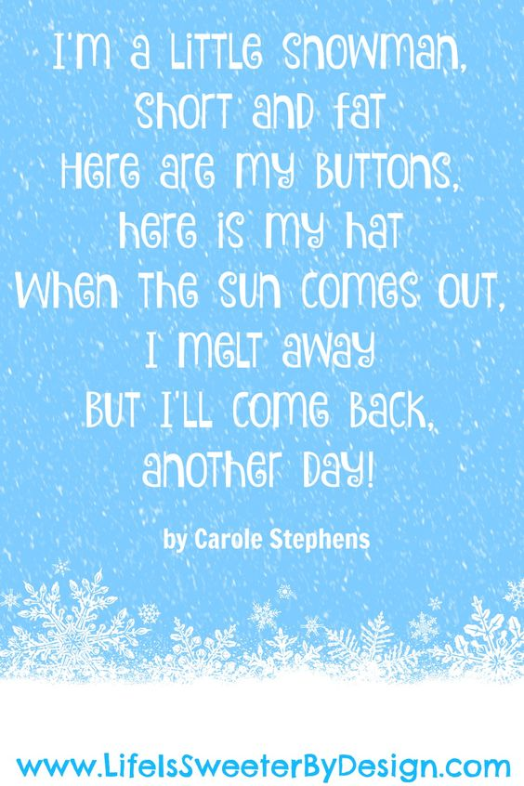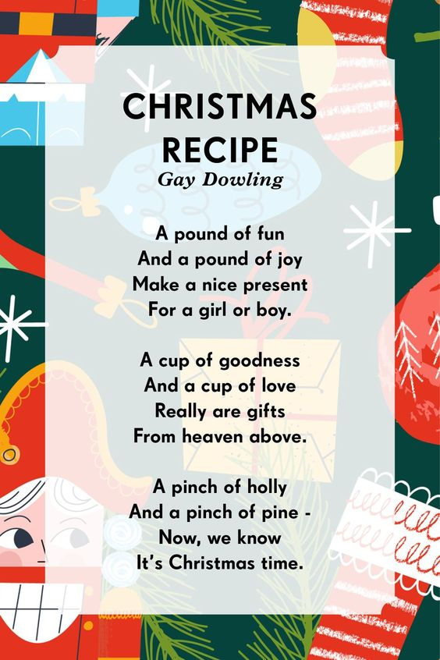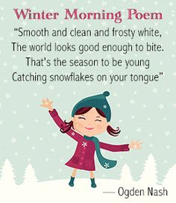
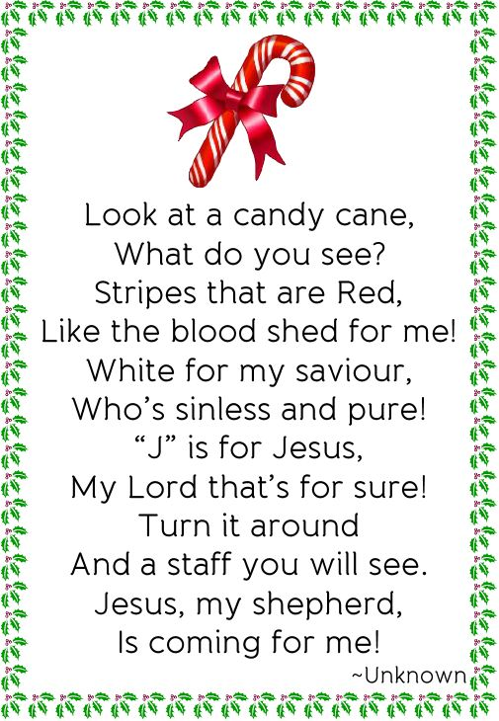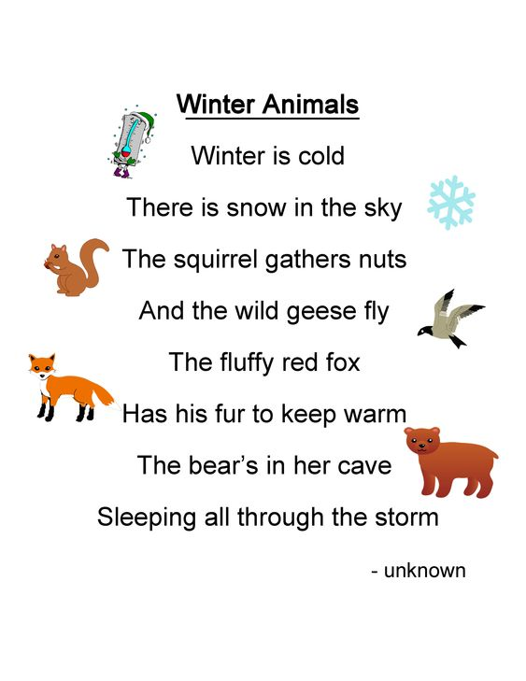
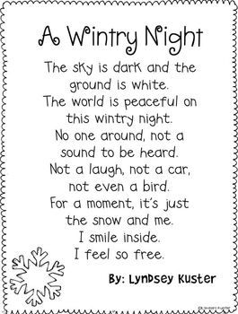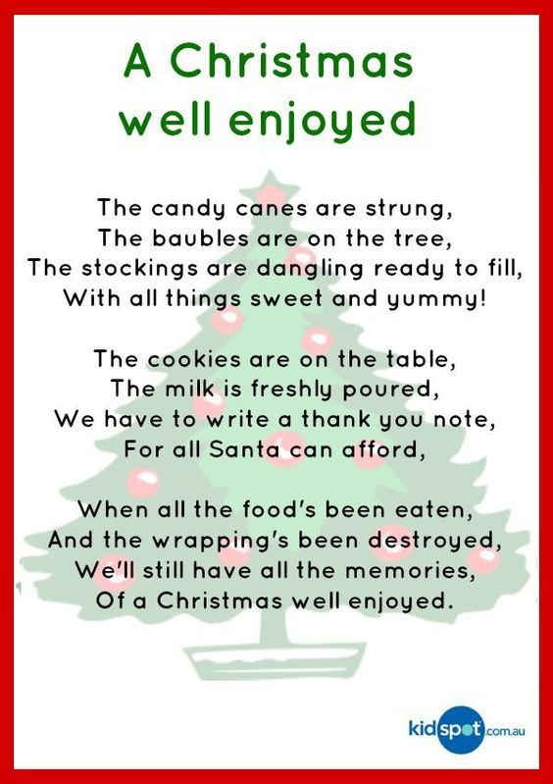
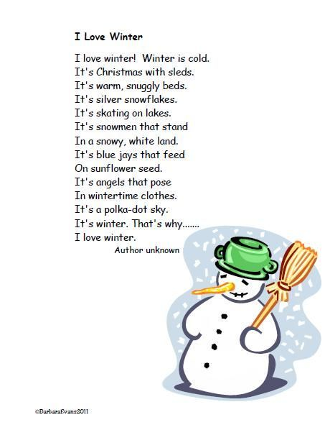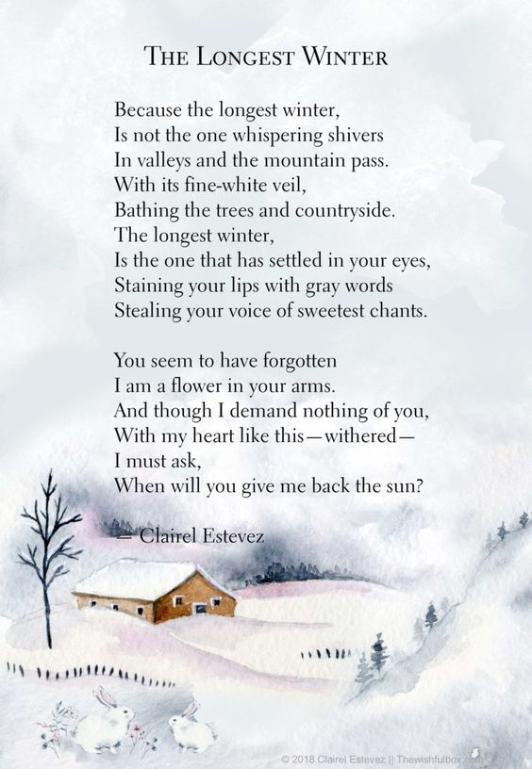

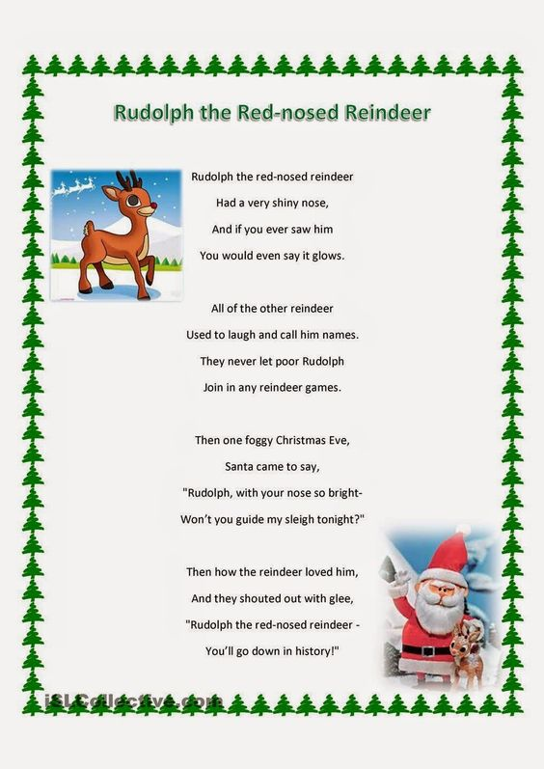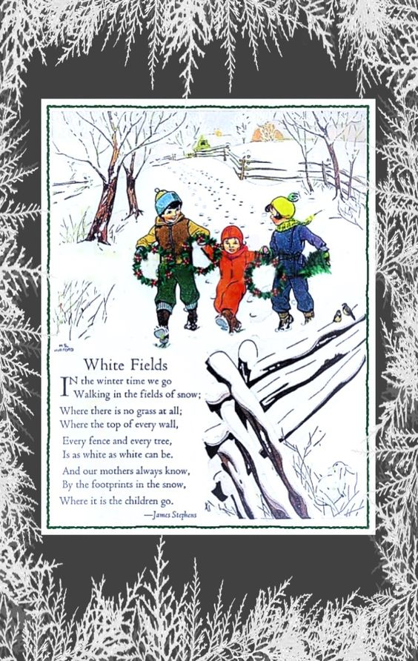
Christmas
By Paulette
C is for Christmas, my favorite time of year,
H is for a Holiday that brings us so much cheer.
R is for Reindeer, that pull Santa’s sleigh.
I is for Icicles, dripping on a warm winters day.
S is for Santa who tried not to be seen.
T is for the Tree, so festive and green.
M is for Mistletoe, for kisses and a hug,
A is for the Angels who at our heartstrings tug.
S is for Stockings, filled up with toys,
for all the eager girls and boys.

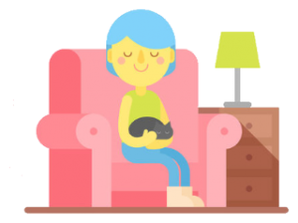  I got a new “laptop” for Christmas  I got a new “laptop” for Christmas.  It’s awesome and couldn’t be cuter.  It isn’t a regular laptop.  It isn’t some kind of computer.  This laptop’s not battery-powered.  It’s missing a keyboard and screen.  It doesn’t connect to the wi-fi.  It’s not some device or machine.  And, yet, I’m in love with my laptop.  You might even say that I’m smitten.  I asked for a laptop for Christmas,  so Santa Claus brought me a kitten.  This winter I went sledding  This winter I went sledding.  I crashed into a tree.  I ran into another one  while learning how to ski.  I slipped upon the sidewalk;  I didn’t see the ice.  A snowball hit me in the face.  (My sister’s not too nice.)  My snowman toppled over.  It landed on my head.  My tongue got frozen to a pole.  I pulled it off. It bled.  I froze my toes and fingers.  They hurt so much I cried.  So, yes, the snow is pretty,  but I think I’ll stay inside.  — Kenn Nesbitt | Spellbound  Emily Brontë  The night is darkening round me,  The wild winds coldly blow;  But a tyrant spell has bound me  And I cannot, cannot go.  The giant trees are bending  Their bare boughs weighed with snow.  And the storm is fast descending,  And yet I cannot go.  Clouds beyond clouds above me,  Wastes beyond wastes below;  But nothing drear can move me;  I will not, cannot go.  Santa  Two merry blue eyes  A very little nose  A long snowy beard  And cheeks like a rose  A round, chubby man  A big, bulging pack  Hurrah for old Santa  We’re glad he’s come back!

