Rozwijanie potencjału społecznego
Charytatywny kiermasz ciast i ciasteczek

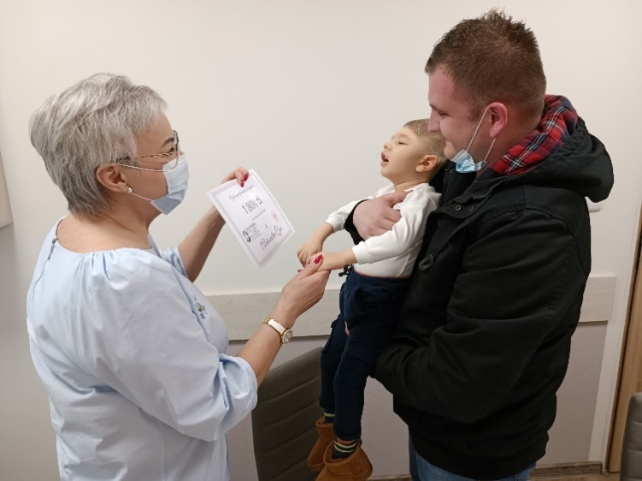

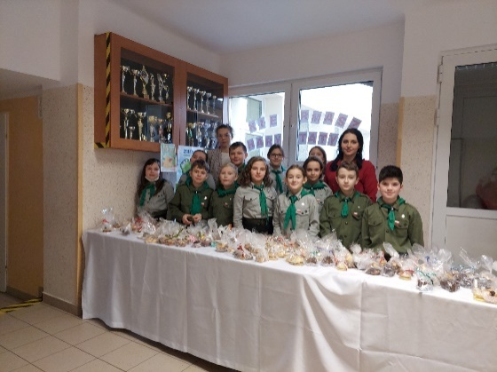
https://spborowa.edupage.org/news/?eqa=bmV3c2FyY2hpdmVmPTIwMjItMDI%3D
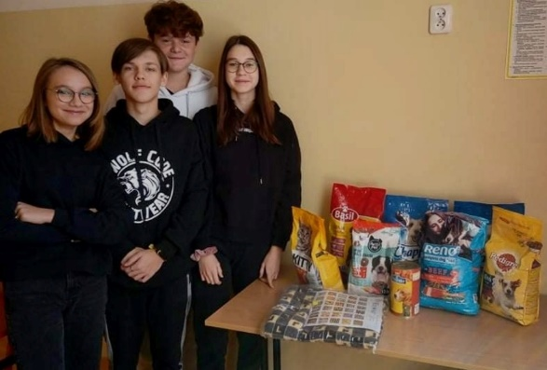
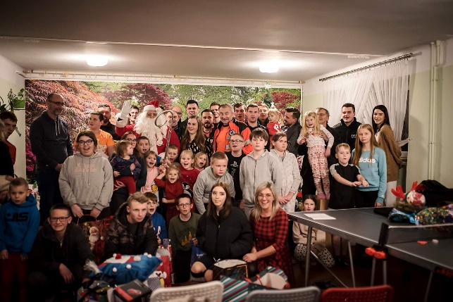
Rozwijanie potencjału społecznego
Podsumowanie działalności wolontariatu
https://spborowa.edupage.org/news/?eqa=bmV3c2FyY2hpdmVmPTIwMjItMDI%3D
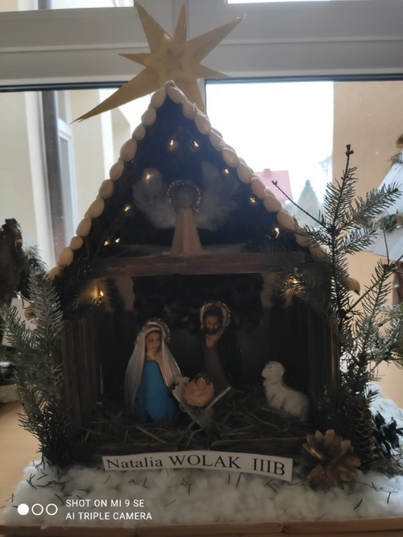
Dbanie o rozwój duchowy
Pożegnanie z Betlejemską Grotą
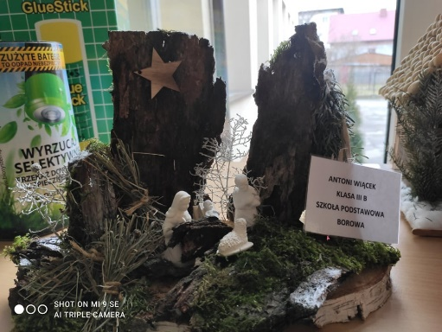
https://spborowa.edupage.org/news/?eqa=bmV3c2FyY2hpdmVmPTIwMjItMDI%3D

Podejmowanie działań charytatywnych

30. FINAŁ WIELKIEJ ORKIESTRY
ŚWIĄTECZNEJ POMOCY ZA NAMI!

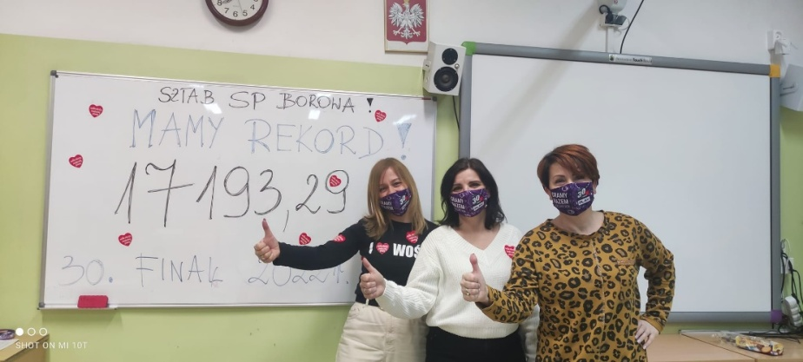
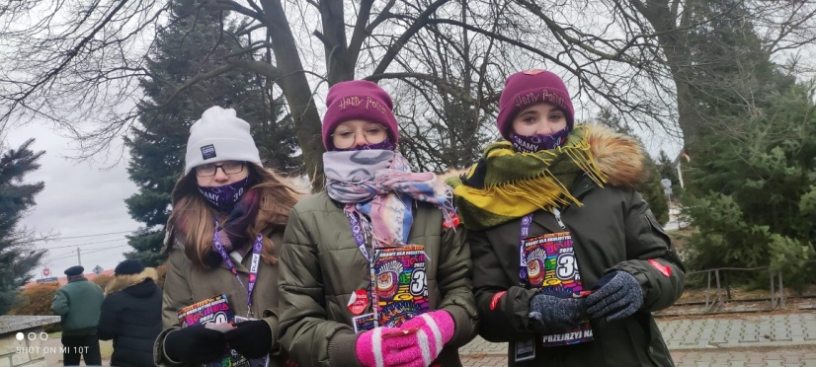
https://spborowa.edupage.org/news/?eqa=bmV3c2FyY2hpdmVmPTIwMjItMDI%3D

Integracja zespołów klasowych
Zabawa karnawałowa
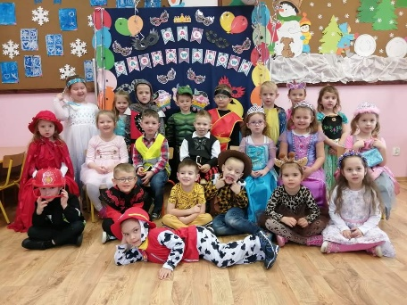
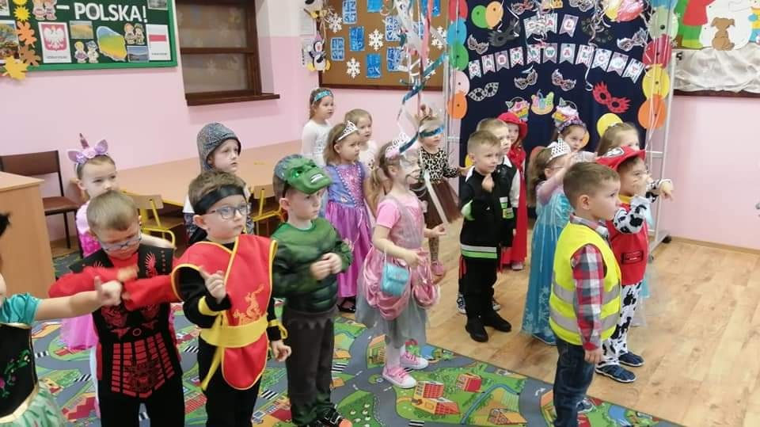

https://spborowa.edupage.org/news/?eqa=bmV3c2FyY2hpdmVmPTIwMjItMDI%3D
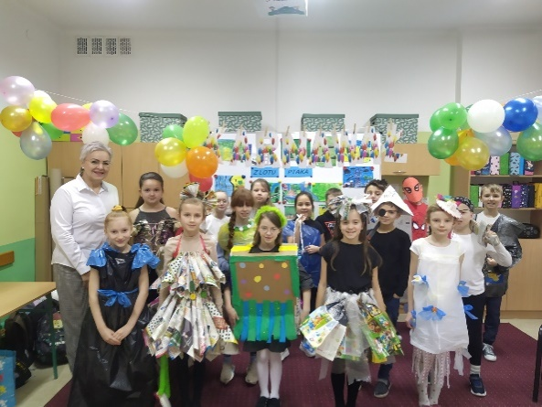
Promowanie postaw ekologicznych
Ekologiczny karnawał
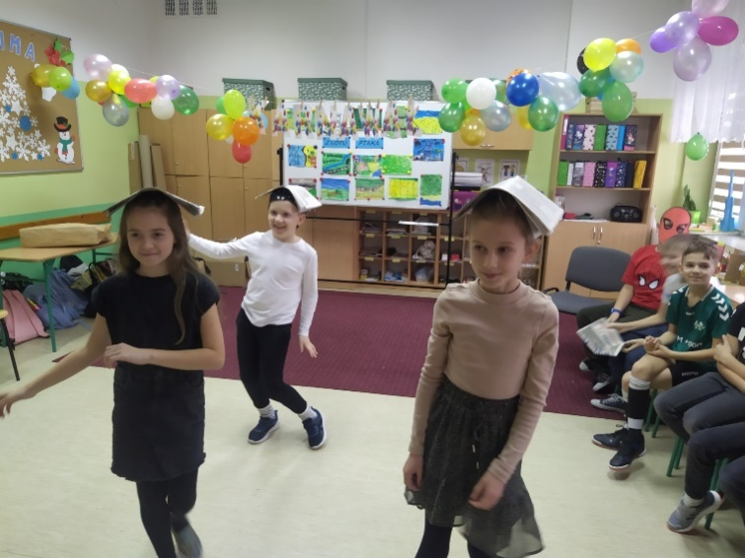

https://spborowa.edupage.org/news/?eqa=bmV3c2FyY2hpdmVmPTIwMjItMDI%3D

Pobudzanie uczniowskiej kreatywności
MY CITY-PROKEKT KLASOWY KLAS III ECO-CITY - recyklingowe makiety miast

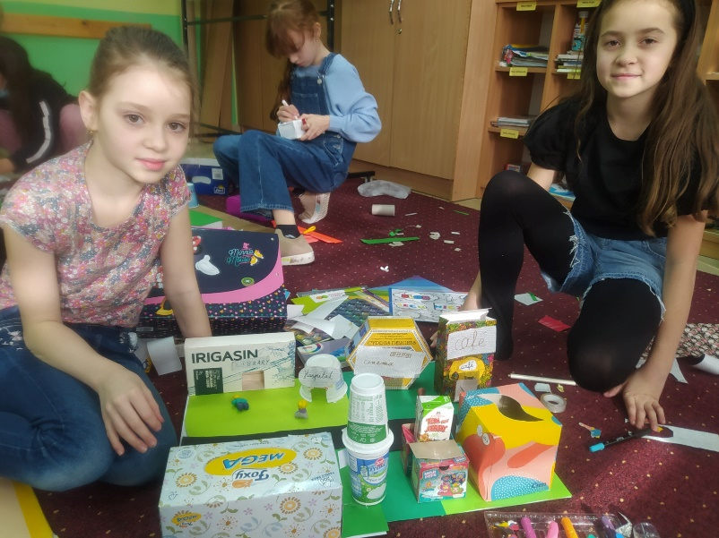
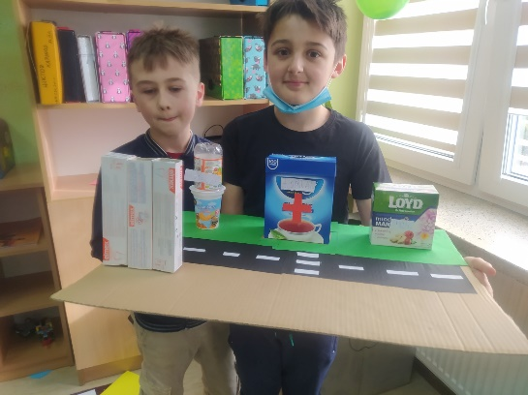
https://spborowa.edupage.org/news/?eqa=bmV3c2FyY2hpdmVmPTIwMjItMDI%3D

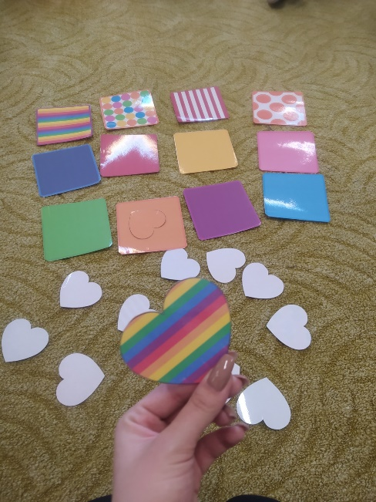
Kształtowanie szacunku do osób starszych
Przygotowanie kartki walentynkowej
z życzeniami w języku angielskim dla p. Irenki, 99 letniej podopiecznej Domu Pomocy Społecznej w Warszawie #walentynkadlaIrenki

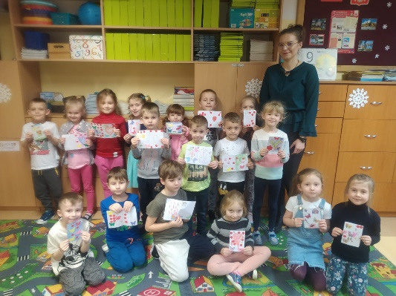
https://spborowa.edupage.org/news/?eqa=bmV3c2FyY2hpdmVmPTIwMjItMDI%3D
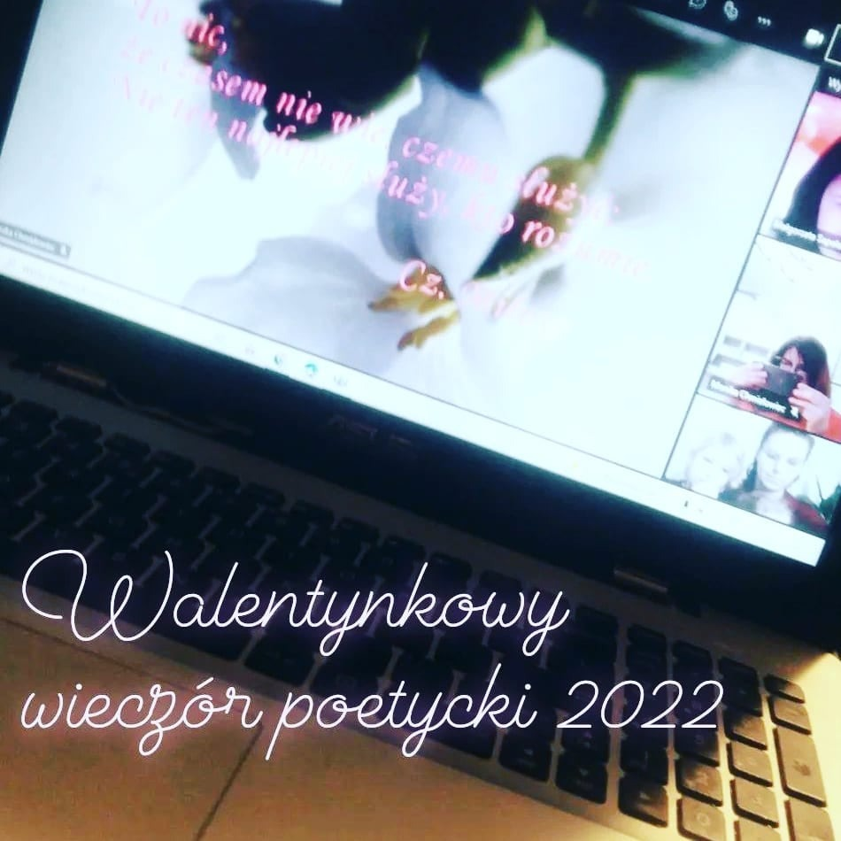
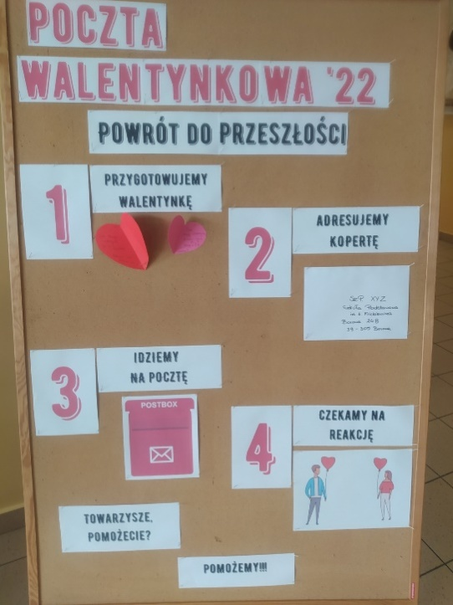
Danie o pozytywne relacje koleżeńskie
Walentynki
https://spborowa.edupage.org/news/?eqa=bmV3c2FyY2hpdmVmPTIwMjItMDI%3D
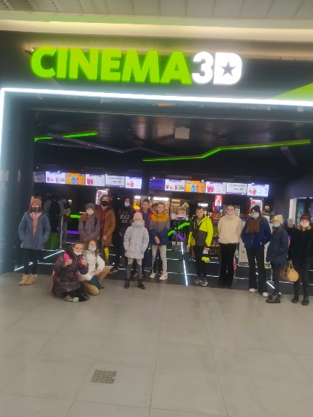
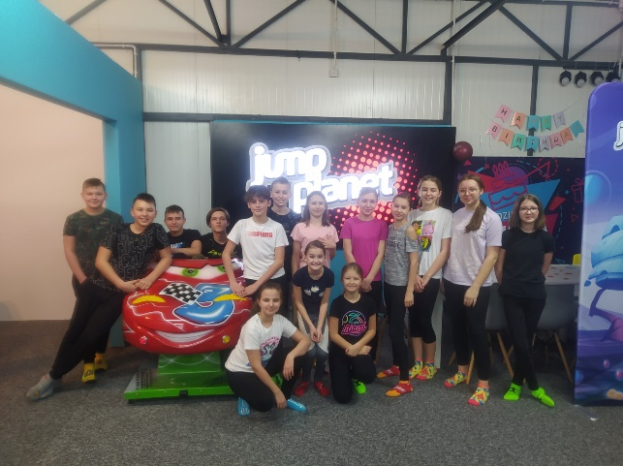
Integracja uczniów
Ferie zimowe- wyjazd integracyjny wolontariuszy oraz członków
Samorządu Uczniowskiego

https://spborowa.edupage.org/news/?eqa=bmV3c2FyY2hpdmVmPTIwMjItMDI%3D

Kształtowanie otwartości na potrzeby innych
Wolontariat

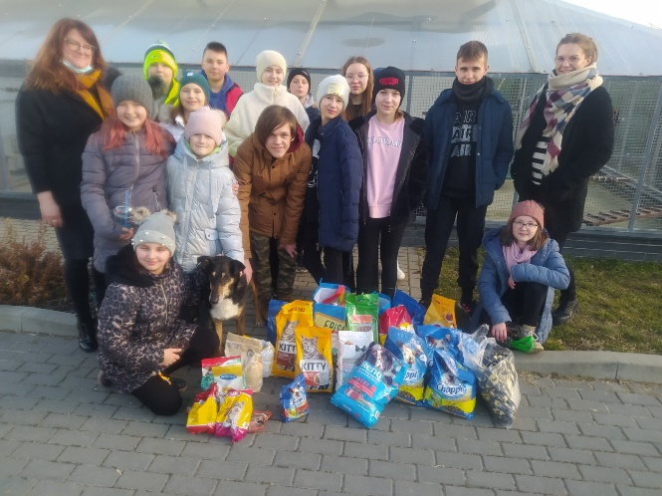
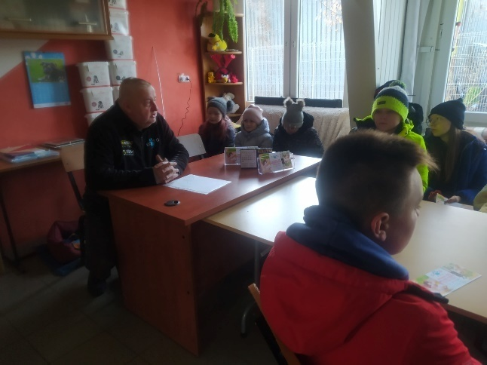
https://spborowa.edupage.org/news/?eqa=bmV3c2FyY2hpdmVmPTIwMjItMDI%3D

